|  |
| --- |
| **Branch:** All Name : malak shehab  **Subject:** Grammar Test **Class:** Grade Four **Section:** (A, B)  **No. of Pages:**2 **Grade**: ………… / **10**  **Duration:** 35 min **Date:** ----/06/2021  **Answers On:** ~~Test Paper~~ / Separate sheet **Allowed:** Pen **Not Allowed:** ~~Pencil~~ |

# I. Read the passage. Choose the following items: ( / 1)

My best friend lives in a nearby street. Last week,my friend’s dog escaped from the yard. She squeezed through the fence and ran down the street. Then they caught her and returned her to the house. Next week, my friend’s father will fix the hole in the fence.

1. one verb in the past tense: Last week
2. one verb in the present tense: Lives
3. one verb in the future tense: Will fix
4. one subject pronoun: My

# II. Write the verb in the correct tense to complete the sentence. ( / 2)

1. Alexander Grahem Bell (invent) invented the telephone in 1875.
2. It (snow) snows heavily in my country every winter.
3. Next weekend, I (go) I will go to the beach with my friends.
4. People usually (travel) travel in summer.

# III. Write the correct pronoun or pronouns in ( ) to complete each sentence. ( /1.5)

1. Lama drinks a glass of milk with lunch. (She, It) she likes milk with cookies too.

1. I like to play soccer and basketball. (They, We) we require plenty of physical exertion.

1. (They, Them) they knew Sam [I , Me] me could take the train by ourselves.

1. Aunt Doris and Uncle Bob were not worried about us (us, we).

1. Alaska is beautiful, and I hope to visit it (it, him) some day.

1

# IV. Complete the text with the *past form* of the verbs in brackets. ( /2.5)

Last Saturday, my dad took my friend, Harry, and me to the circus. My dad bought (buy) us some popcorn and orange juice. We saw lots of things at the circus. There was (be) some lions. They did (do) some tricks; they jumped through hoops. A girl rode (ride) an elephant around the ring.

We had (have) a lovely time at the circus.

**V. Proofread the following paragraph. There are six mistakes in subject-verb agreement. (1.5)**

In summer, I went to the park near my house. My sister, Lina, and I played together. Our grandmother sat on a bench and watches us. Later, the ice cream truck arrived . Lina and I raced to be first. I ask for chocolate, and my sister ask for strawberry. As we walked home, my grandmother picked some flowers.

# VI. How will you spend your summer vacation? Write at least two sentences. ( /1.5)

I will go to the mountain and spent my summer .

And I will visit my grandma every day .

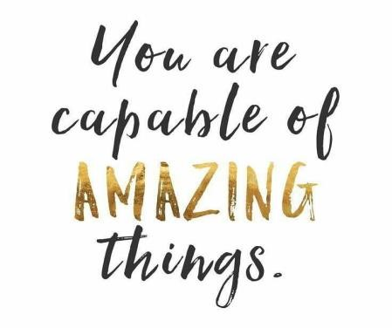

2